**Data**

In reviewing the data provided by Citi Bike, I decided to use Jersey City data for my project. The number of records for Jersey City is 1,081,108 for the dates between May 2015 through July 2019. Since 2015 and 2019 aren’t full years, I excluded them from my YOY growth analysis. From 2016 to 2017, total ridership increased 20% and from 2017 to 2018, total ridership increased 21.6%.

In reviewing growth by quarter, Q2 has grown significantly year over year. From 2016 to 2017, Q2 grew 33%. From 2017 to 2018, ridership grew by 25% and from 2018 to 2019, ridership grew by just 5%.

Most of the ridership growth is due to significant increase in subscribers. For the winter months, for example, (December, January & February) there has been a significant increase year over year. Specifically, ridership increased by 54% when comparing January 2019 to 2018. For the summer months (June, July, and August), there was a significant increase overall from 2017 to 2018 but from 2018 to 2019, subscribers fell by 2% while Daily Customers increased by 130% for July 2019.

It’s important to note that the % Difference calculations for each prior period are included in the tooltip using the Table Calculation function in Tableau.

**Start Station map & End Station Map**

For both start and end stations, the Grove Street Path station is by far the most used bike station in New Jersey. Considering all years, the Grove Street Path station has 133,758 start rides and 169,138 end rides.

The Top 10 Start Stations in Jersey City are as follows:

* Grove Street PATH
* Hamilton Park
* Exchange Place
* Sip Avenue
* Newport PATH
* Newark Avenue
* Van Vorst Park
* Warren Street
* Newport Parkway
* Brunswick Street

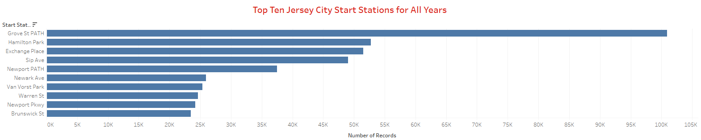

The Top 10 End Stations are as follows:

* Grove Street PATH
* Hamilton Park
* Newport PATH
* Exchange Place
* Newport Parkway
* Warren Street
* Essex Light Rail
* Newark Avenue
* City Hall
* Sip Avenue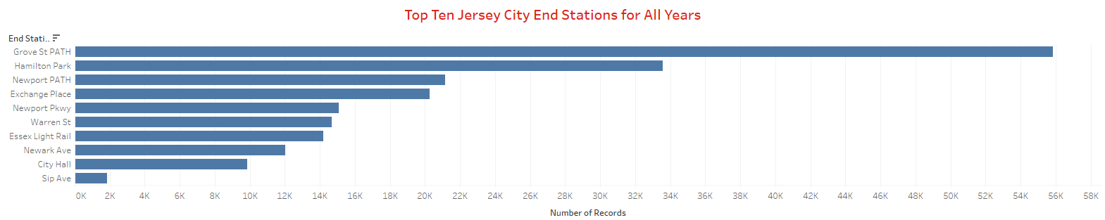

The bottom 10 start stations are:

* West Side Light Rail
* MLK Light Rail
* Bayside Park
* Columbia Park
* Jackson Square
* Danforth Light Rail
* Bethune Center
* JCBS Depot

The bottom 10 end stations are:

* Brunswick & 6th
* E 2 st and 2 Ave E
* Harborside
* Montgomery Street
* North Street
* W 34th Street & 11th Avenue
* York Street
* Fairmount Avenue
* Grand Street
* Monmouth and 6th

My hypothesis is that most commuters ride the Citi Bike to the Grove Street Path station to take the PATH train into midtown or lower Manhattan. There are also a lot of businesses in that area, like Goldman Sachs and Etrade, and riders could be commuting to work in Downtown Jersey City. Riders are also riding Citi Bikes where it is bike friendly or where there are bike lanes. West Side Light Rail, for example, is alongside a very busy rode that does not have bike lanes.

**Ridership by Gender**

Although there is a gender outreach to attract more female riders, ridership is still dominated by male subscribers.

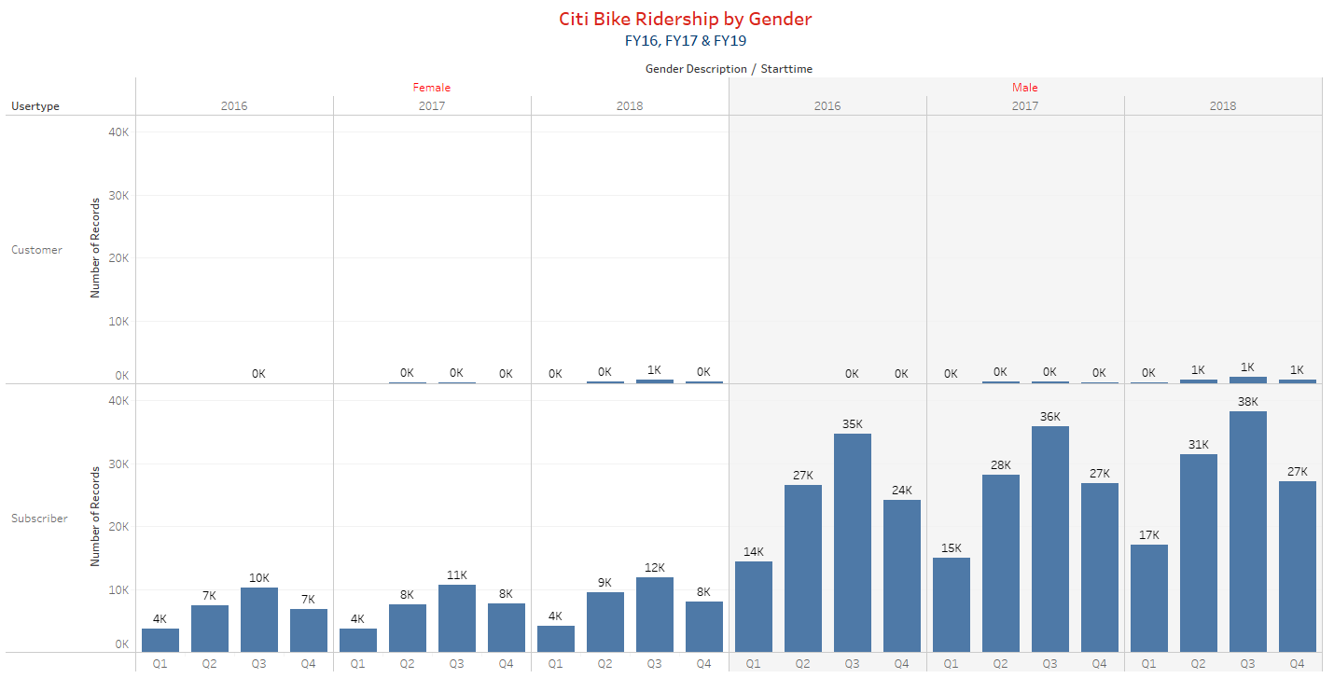

**Ridership by Age**

While most riders are born in the 1980s or 1990s, with an average trip duration of 10.23 minutes. It’s important to note that there is a huge spike in trip duration for those born in the 2000s but that doesn’t affect the overall average since the majority of trips are taken by those born in the 1980s or 1990s.

To calculate trip duration in minutes, I needed to divide total trip duration by 60, since the trip duration provided in the original dataset was in seconds, not minutes. 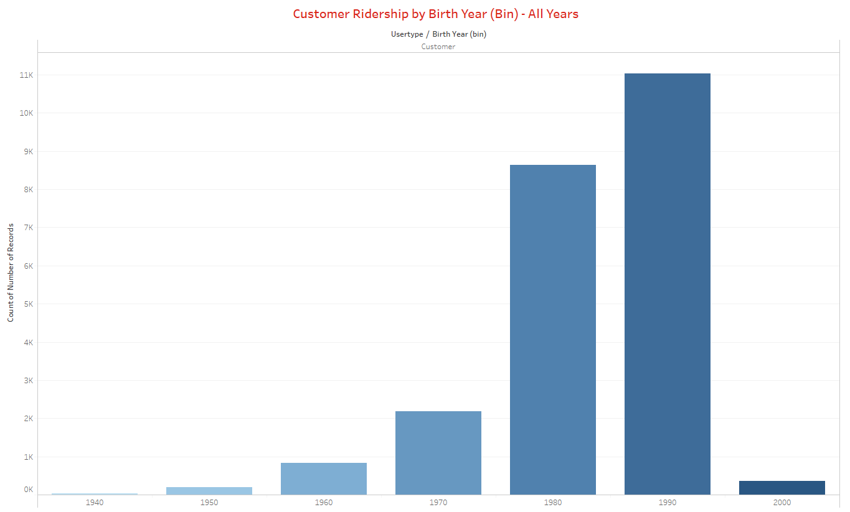

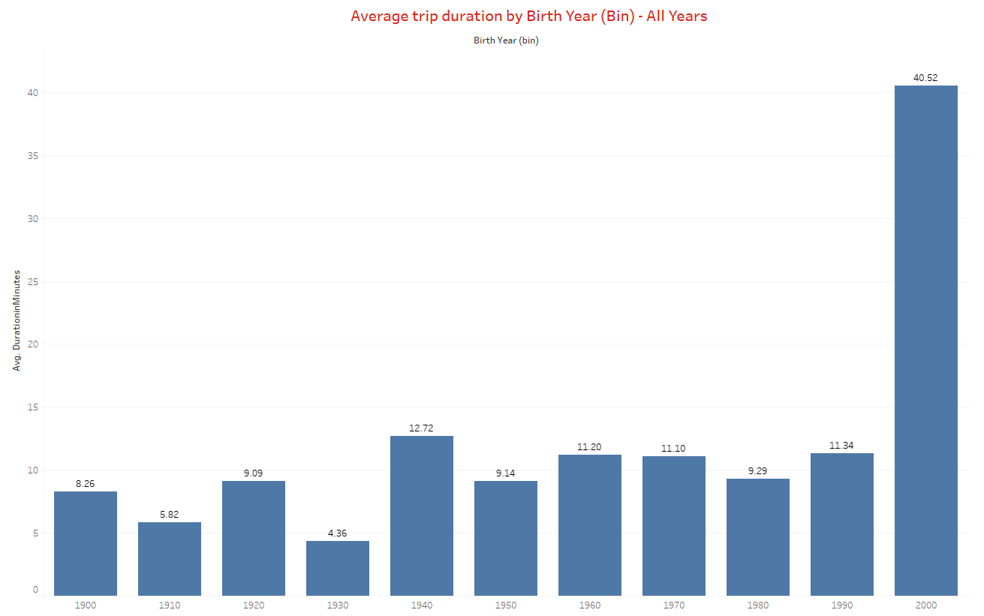

**Outliers**

Several records supposed that riders were 132 years of age. Also, some records had an ending station that said “Do not use.” In both instances, I excluded this data from my dataset.